University of Computer and Emerging Sciences



Laboratory Manual
for

Web Engineering Lab

Course Instructor | Sir Mudassir Saeed
Lab Instructor | Marwa Khan
Section | BSE-6A
Semester | Spring 2024

Department of Computer Science
FAST-NU, Lahore, Pakistan

Objective(s):
- The objective of this lab task is to learn how to create a form.
- The objective of this lab task is to learn how to apply different properties of css to give a web page a professional look.

Lab Tasks:

Task 01:
Create a form.

Sample Output:

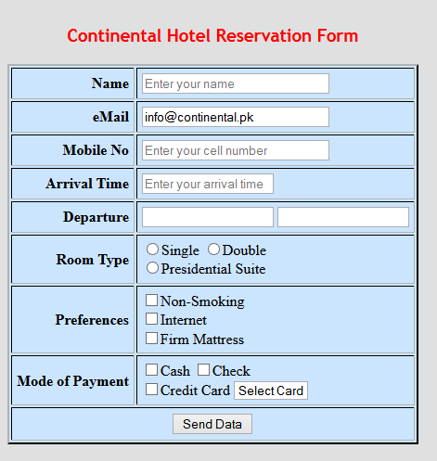

Task 02:
The task is to organize journal.html by adding ids, classes, spans and divss. Then, add "boxes" around these sections of the website by adding to style sheet.
- Apply border, margin and padding properties.
- Apply float, font-family and font-weight properties.

Sample Output:

